# Your Name: ________________________________ Student Number: _______________________

# Lab 5a: at home, alone – due next class (in person at the end of NEXT lab)

Reference: https://developer.mozilla.org/en-US/docs/Web/API/Node

and

http://www.w3schools.com/jsref/dom_obj_all.asp

Create a javascript / html file that has the following behaviors:

There will be fifteen images in the body of the page. They must be named 0.jpg, 1.jpg, 2.jpg, …, up to 14.jpg. Use JavaScript to create the images, after the window finishes loading.

After that, five divs are created using javascript. The top div contains an h1 heading with the text “Image Liker by <Tiger Woods>” (but use **your own name**, not Tiger Woods). The bottom div contains an **<input type=’button’>** button with the value “reset”.

The second, third, and fourth divs must have IDs of 0, 1, and 2, respectively. Each of these divs has an h2 text node in it with the text “All Images,” “Images I Like,” and “Images I Hate,” respectively. The class name of each of these h2 elements must be “instructions”. Each div’s h2 element must remain as the first element in the div, and never move, and never have images to its left within its own div.

When the window finishes loading, div 0 is populated with all 15 images. Use JavaScript to style the css to give each image a width of 120px, a margin of 4px, and a border style of “red solid 1px”.

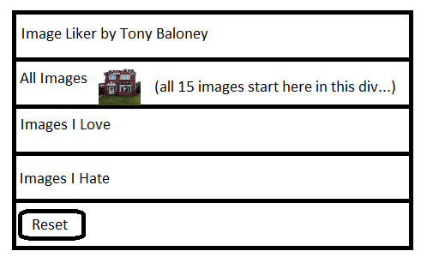

When an image is clicked with the mouse, it must move *after* (i.e. to the right of) its right-neighboring image. If the image is already the rightmost image in its div, it moves to the next div, in this order: 0->1, 1->2, 2->0 (i.e. from div 0 to div 1; from div 1 to div 2; from div 2 to div 0); make sure you ignore the h2 elements.

When the reset button is clicked, everything is reset to the original state as when the page is first loaded (all images return to div 0, etc…).

Make sure you include all of your images with your submission. Put all of your files into one folder, zip that folder, name the folder in the format firstname_lastname_lab5a.zip, and upload that zip file to BCIT’s Desire To Learn Lab 5 dropbox.

Name your lab exactly as follows:

lastname-firstname-lab-#.zip

Example: **woods-tiger-lab-5a.zip** or **sheen-charlie-lab-5a.zip**

# Lab 5b: at home, alone – due next class (in person at the end of NEXT lab)

Add another div to your page, using JavaScript again. Its id must be “3”. Its h2 element must have class name “instructions” and its text must be “favorites of all time”. When the last image from div 2 is clicked, it must be appended to this div. When the last image from this div (div 3) is clicked, it must be appended to div 0. When an image is clicked with the mouse, it must move *after* (i.e. to the right of) its right-neighboring image. If the image is already the rightmost image in its div (make sure you ignore the “instructions” h2 elements), it moves to the next div, in this order: 0->1, 1->2, 2->3, 3->0 (i.e. from div 0 to div 1; from div 1 to div 2; from div 2 to div 3; from div 3 to div 0). In other words, it works exactly similarly to the other three image divs.

Also include a new image (with a width of 100px) at the very bottom of the document body. When the mouse is over this image, its width grows by 1px every 100ms. When this stationary image is clicked, the image moves down the page 1px every 100ms; when this image is moving and is clicked, it stops. In other words, clicking this image toggles whether it is moving or not.

Make sure you include all of your images with your submission. Put all of your files into one folder, zip that folder, name the folder in the format firstname_lastname_lab5b.zip, and upload that zip file to BCIT’s Desire To Learn Lab 5 dropbox.

Name your lab exactly as follows:

lastname-firstname-lab-#.zip

Example: **woods-tiger-lab-5b.zip** or **sheen-charlie-lab-5b.zip**